
SAVEETHA SCHOOL OF ENGINEERING

SAVEETHA INSTITUTE OF MEDICAL AND TECHNICAL SCIENCES
DEPARTMENT OF COMPUTER SCIENCE AND ENGINEERINNG

DAY 2 ANALYTICAL QUESTIONS.

- Identify the error in program
#include<iostream>
void main()
{
int i=0;
i=i+1;
cout<<i<<" ";
cout<<i;
}
output for the program for the errors: 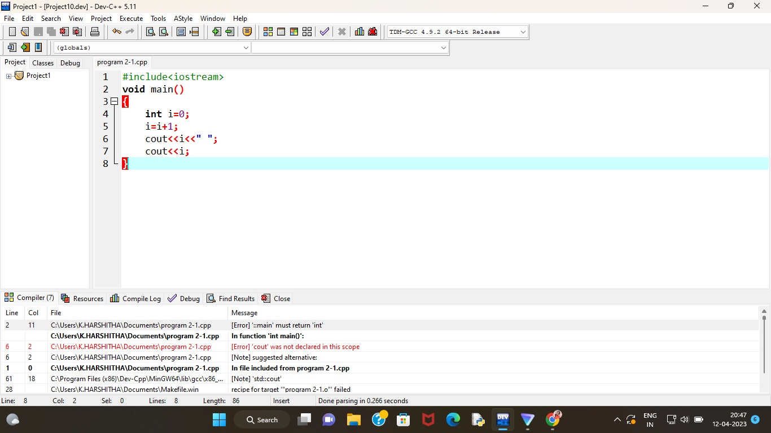

- Identify the error
#include<iostream.h>
void main()
{
short i=2500, j=3000;
cout>>" i+j ">>=(i+j);
}

Output for the given program consists of following errors:
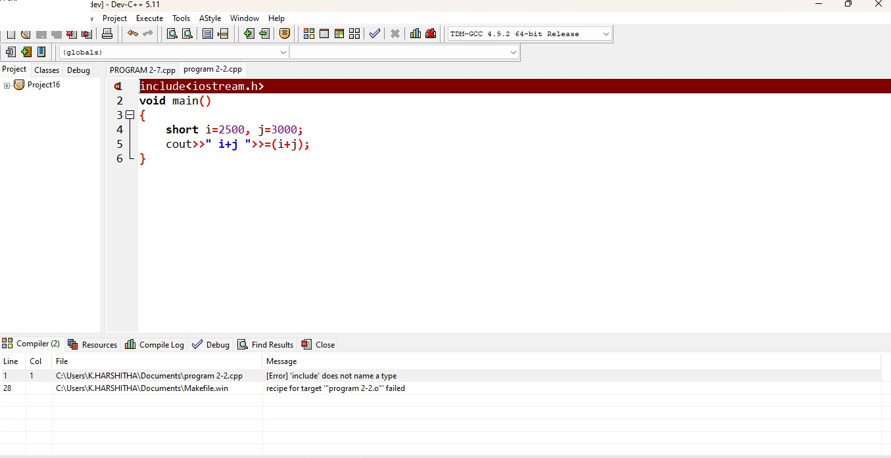

Answer:

using namespace std;
#include<iostream>
int main()
{
short i=2500, j=3000;
cout<<" i+j "<<i+j;
return 0;
}

- What will happen when you run following program.
/*
#include<iostream.h>
void main()
{
int i=10, j=5;
int modresult=0;
int divresult=0;
modresult=i%j;
cout<<modresult;
divresult=i/modresult;
cout<<divresult;
}
Output for the given program:
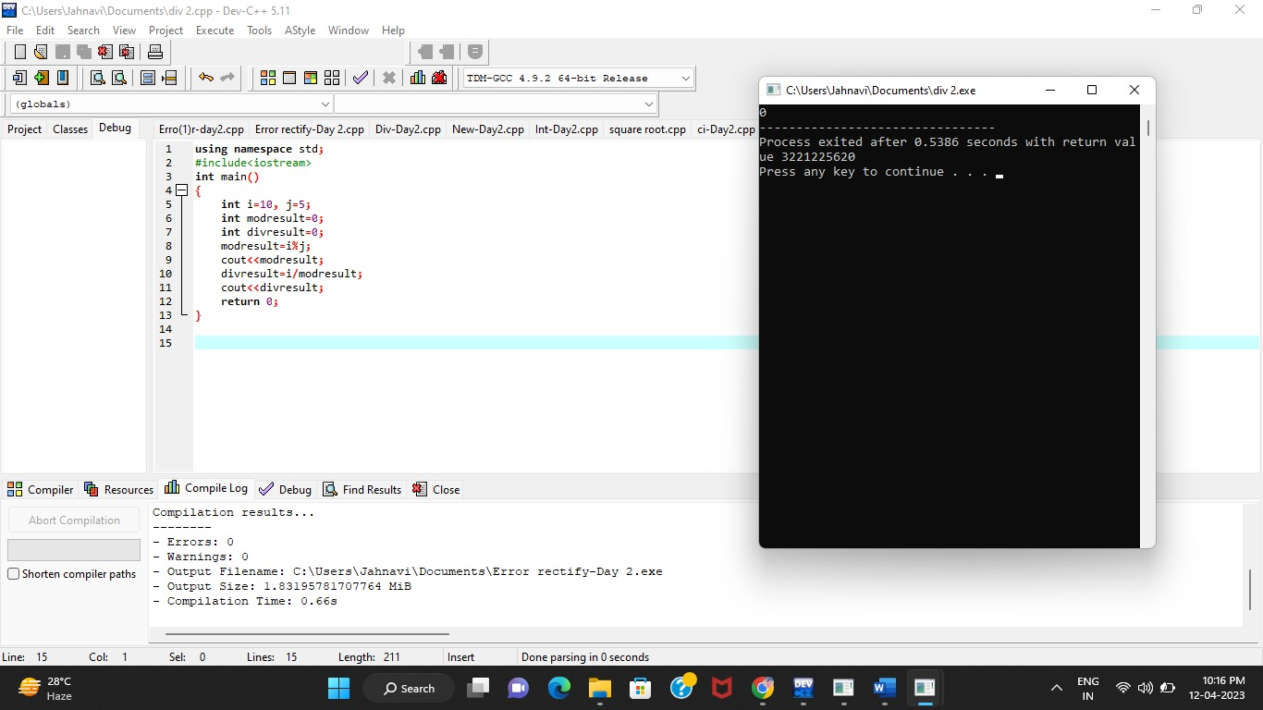
*/

using namespace std;
#include<iostream>
int main()
{
int i=10, j=5;
int modresult=0;
int divresult=0;
modresult=i%j;
cout<<modresult;
divresult=i/modresult;
cout<<divresult;
return 0;
}
Output for the given program:
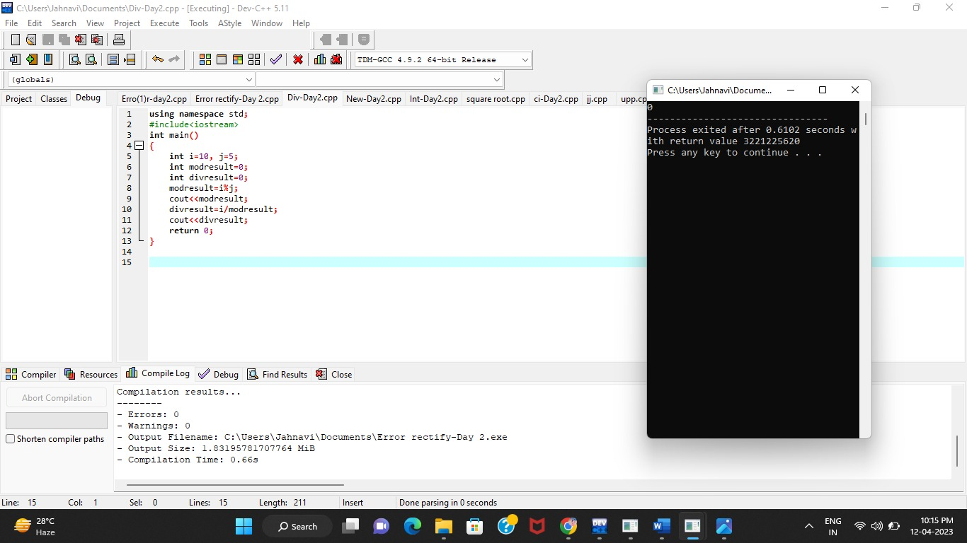

- Write a c++ program

What happens if the following program is executed in C and C++?
/*
#include <stdio.h>
int main(void)
{
const int j = 20;
int *ptr = &j;
printf("*ptr: %d\n", *ptr);
return 0;
}
Output for the given program in c:

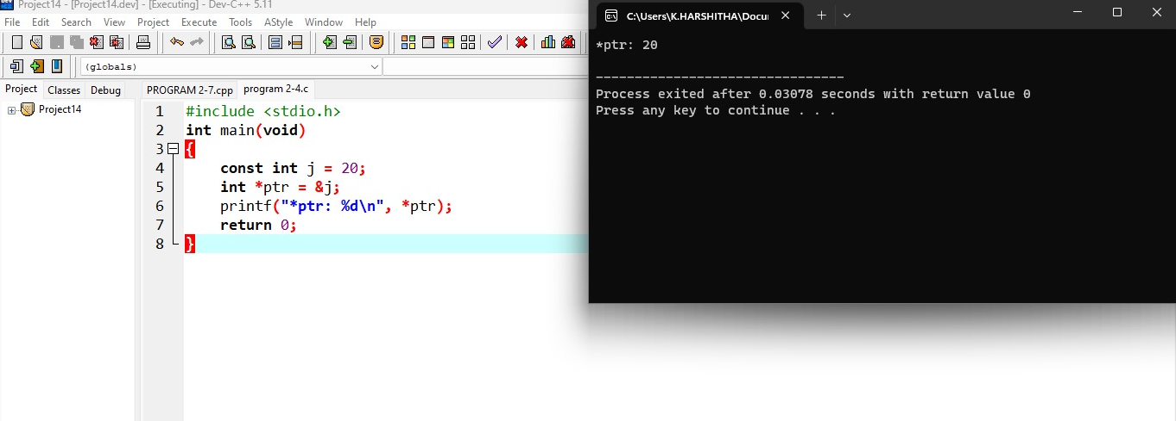

using namespace std;
#include<iostream>
int main(void)
{
int j = 20;
int *ptr = &j;
cout<<(*ptr);
return 0;
}
Output for the given program in c++:
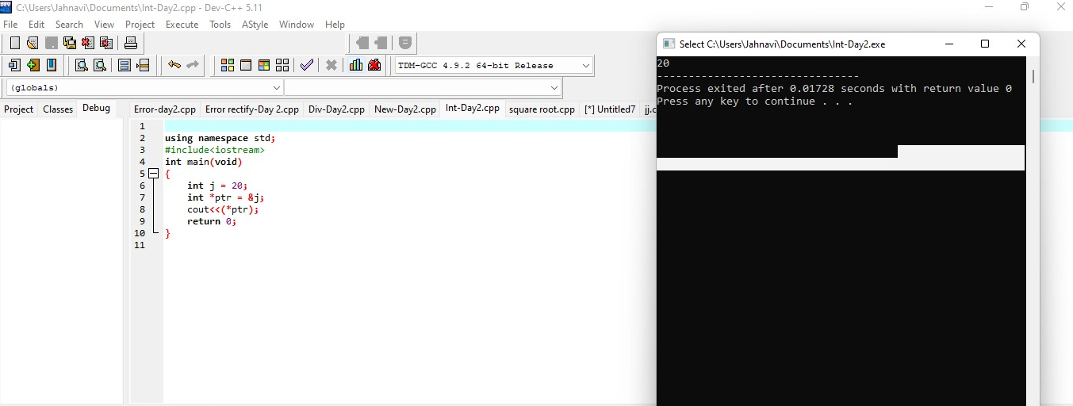
- What happens if the following program is executed in C and C++?
/*
#include <stdio.h>
int main(void)
{
int new = 5;
printf("%d", new);
}

*/
Output for the given program in c:
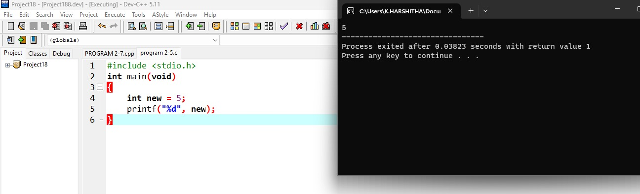

- Write c++ program for finding Square root of number.

#include<iostream>
#include<math.h>
using namespace std;
int main()
{
float sq,n;
cout<<"enter any number:";
cin>>n;
sq=sqrt(n);
cout<<"root of number:"<<sq;
}
Output for given program:
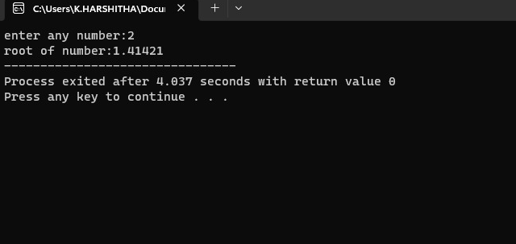
- A person wants to find his birthday day, but he has known no of days present only.
Find the no of days, no of years and no of weeks present for his birthday.
#include <bits/stdc++.h>
using namespace std;
#define DAYS_IN_WEEK 7
void find(int number_of_days)
{

int year, week, days;
year = number_of_days / 365;
week = (number_of_days % 365) / DAYS_IN_WEEK;
days = (number_of_days % 365) % DAYS_IN_WEEK;
cout << "years = " << year;
cout << "\nweeks = " << week;
cout << "\ndays = " << days;
}
int main()
{
int number_of_days = 200;
find(number_of_days);
return 0;
}
Output for given program:
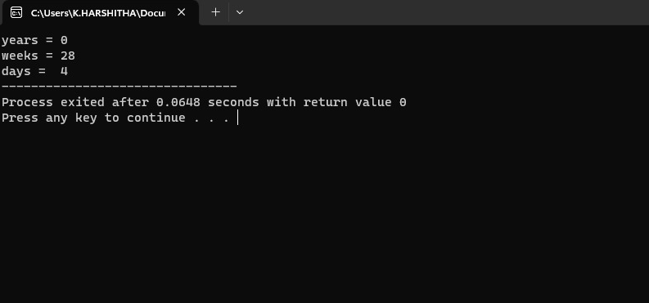

- A person wants to invest amount in financial institution and he wants find the compounded interest he will get, if no of year 385000, roi is 13.89 and time period is 4.
Write the code for above scenario.
#include<iostream>
#include<math.h>
using namespace std;
int main()
{
float p,t;
double r,ci;
cout<<"enter the principal amount:";
cin>>p;
cout<<"enter the time period:"<<endl;
cin>>t;
cout<<"enter the rate of interest:"<<endl;
cin>>r;
ci=p*pow((1+r/100),t);
cout<<"the compound interest is :"<<ci<<endl;

}

Output for the given program:
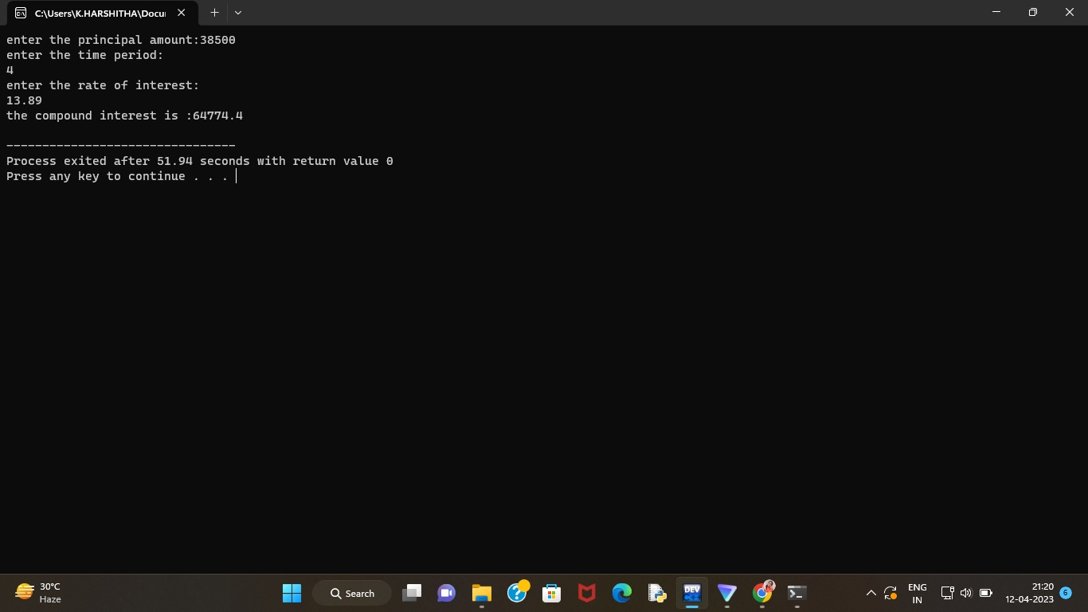

- C++ Program to Check Character is Uppercase, Lowercase, Digit or Special

#include<iostream>
using namespace std;
int main()
{
char ch;
cout<<"enter any character/value to check:";
cin>>ch;
if(ch>=65&&ch<=90)
{
cout<<"the entered character is an uppercase"<<endl;
}
else if(ch>=48&&ch<=57)
{
cout<<"the entered value is a digit"<<endl;
}
else if(ch>=97&&ch<=122)
{
cout<<"the entered character is a lower case"<<endl;
}
else
{
cout<<"the entered character is a special character"<<endl;
}
}

Output for the given program:
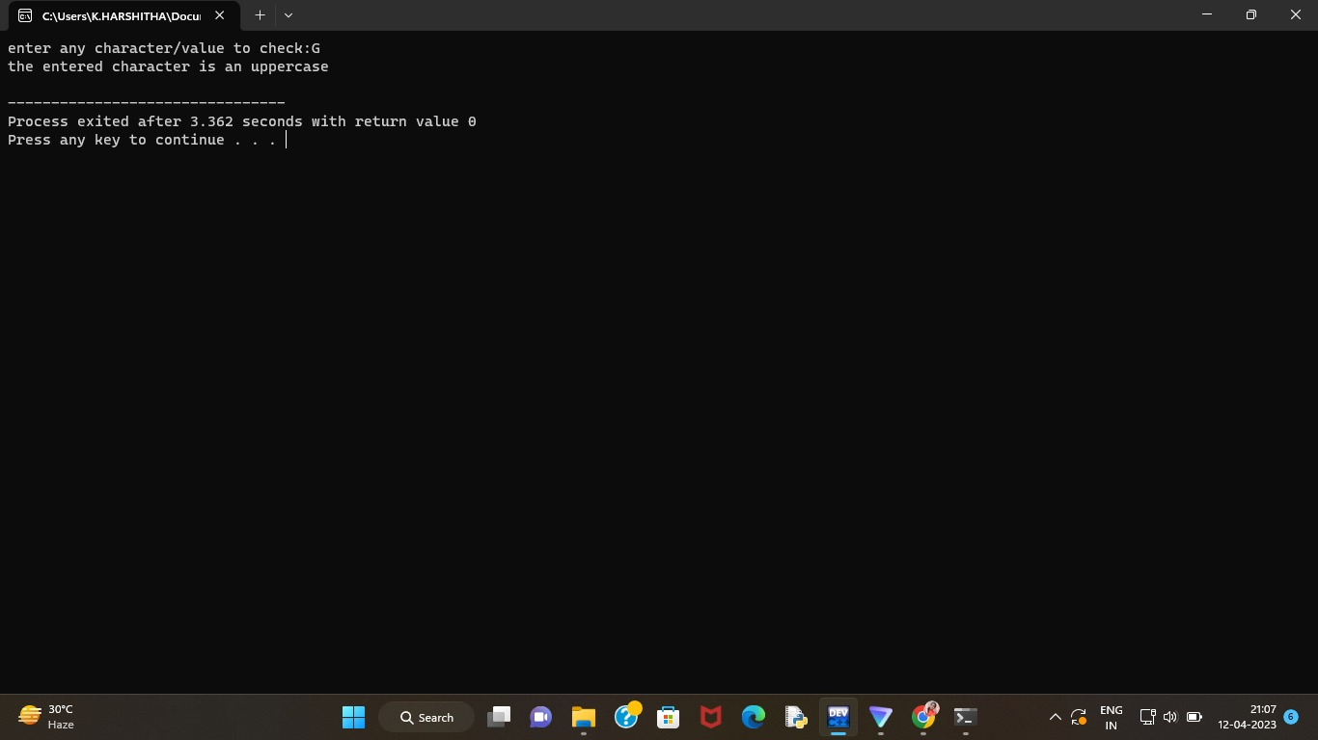

- Write a program to display ascii value of character.

#include <iostream>
using namespace std;

int main()
{
char c;

cout << "Enter any Character : ";
cin >> c;

cout << "\nThe ASCII Value of Character "<< c << " is :: " << int(c)<<endl;

return 0;
}

Output for the given program:
